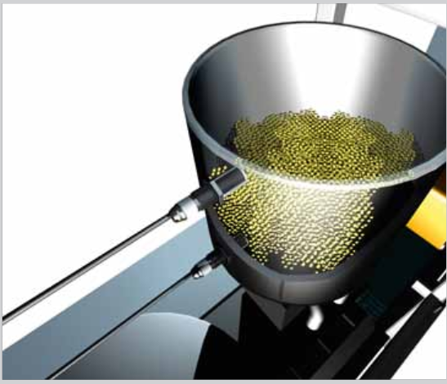Capacitive Sensors

We decided to looking for capacitive sensors which have a thread size of 30 because it’s where we find the best switching distance.

|  |  |  |  |  |  |  |
| --- | --- | --- | --- | --- | --- | --- |
| Name | Switching distance | Installation | Adjustment | Switching output | Connection type | Price |
| KD/KL 30 | 1 -> 20 mm | Flush / non-flush | Potentiometer | PNP or NPN | Plug M12 4-pin |  |
| CM30-25NNP-EW1 | 4 -> 25 mm | Non flush | Potentiometer | NPN or PNP | Cable, 4-wire, 2m (do not bend below 0 °C) |  |
| CM30-25NNP-EW1 | 4 -> 25 mm | Non flush | Potentiometer | NPN or PNP | Male connector M12, 4-pin |  |
| CM30-16BPP-KC1 | 2 -> 16 mm | Flush | Potentiometer | NPN or PNP | Male connector M12, 4-pin |  |
| CM30-16BPP-KC1 | 2 -> 16 mm | Flush | Potentiometer | NPN or PNP | Cable, 4-wire, 2m (do not bend below 0 °C) |  |